**7.4 translators**

**Name ____________　 class____________**

1. Why does a program, written in a high level language, need to be translated before it can be run on a computer?

________________________________________________________________________________________________________________________________________

____________________________________________________________________

__________________________________________________________________[2]

1. Three examples of language translators and four definitions are shown below.

Draw lines to link each language translator to the correct one or more definitions.

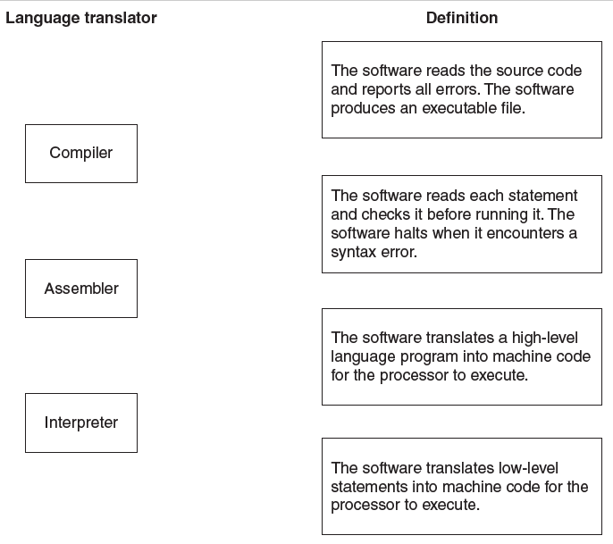

[3]

1. A game program is written which can be either interpreted or compiled. The table below shows five statements about the use of interpreters and compilers.

Tick (✓) to show whether the statement refers to an interpreter or to a compiler.

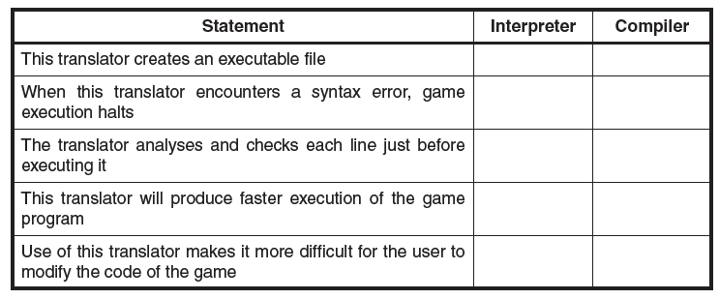

[5]

4.

**(a)** The diagram shows three items of software that translate program code.

Draw **one** line from each context to the correct item of translation software.

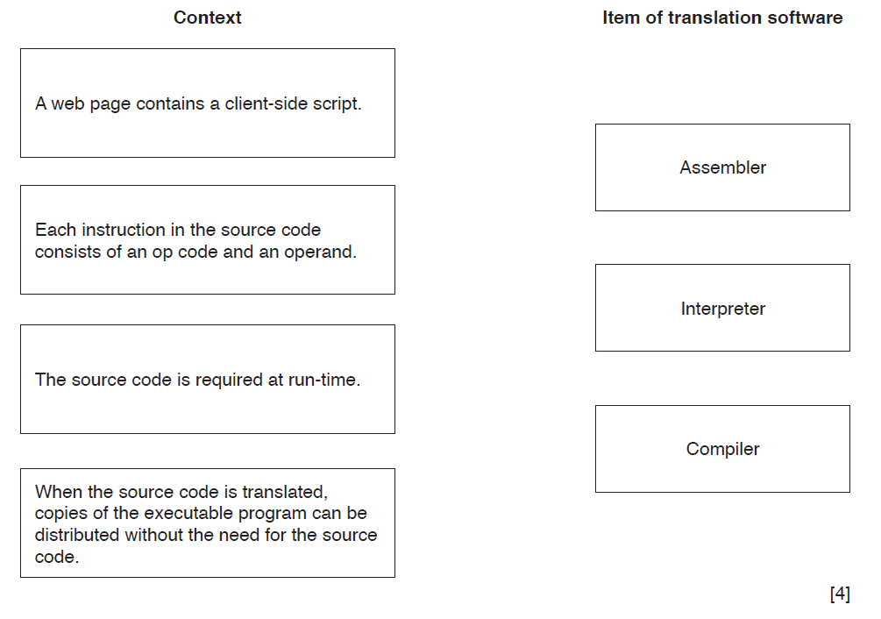

**(b)** The Java programming language is said to be machine or platform independent.

**(i)** Describe what is meant by **machine independent**.

.......................................................................................................................................

..................................................................................................................................[1]

**(ii)** Describe how a Java source code program is translated.

.......................................................................................................................................

.......................................................................................................................................

.......................................................................................................................................

...................................................................................................................................[2]

5.

Programmers working for a software development company use both interpreters and compilers.

**(i)** The programmers prefer to debug their programs using an interpreter.

Give **one** possible reason why.

.......................................................................................................................................

...................................................................................................................................[1]

**(ii)** The company sells compiled versions of its programs.

Give a reason why this helps to protect the security of the source code.

.......................................................................................................................................

...................................................................................................................................[1]